

**Financial Markets and Household Consumption**

Speech given by

Timothy Besley, Member of the Monetary Policy Committee, Bank of England

At the Institute for Fiscal Studies, London 18 February 2008

[Accompanying paper](http://www.bankofengland.co.uk/archive/documents/historicpubs/speeches/2008/speech334paper.pdf)

I would like to thank Charlie Bean, Andrew Holder, Neil Meads, Sally Reid, Nicola Scott, Paolo Surico and Garry Young for comments and assistance. The views expressed are my own and do not necessarily reflect those of the Bank of England or other members of the Monetary Policy Committee.

1

All speeches are available online at [www.bankofengland.co.uk/publications/Pages/speeches/default.aspx](http://www.bankofengland.co.uk/publications/Pages/speeches/default.aspx)

Ladies and Gentlemen, thank you for coming. It is a great pleasure to be addressing you here at the IFS with which I am proud to have had a long­standing association as a Research Fellow. The IFS provides formidable commentaries on economic policy issues in the UK and brings to bear the best economic analysis and evidence to issues that it studies. When it comes to formulating policy, I am firmly of the view that there is no substitute for a good balance of economic analysis and evidence.

Recent events are making the job of the MPC extremely challenging. As you are well aware, the UK economy has in the past few months experienced significant shocks with implications for both inflation and activity. Rising energy and food prices, along with a lower exchange rate, will increase inflation in the near term. At the same time, recent turmoil in financial markets is resulting in tighter credit conditions. This is leading to a weaker picture for world growth which, along with its direct effect on the UK, is posing a downside risk to growth in demand and output. Responding to either of these events on its own would be challenging. But the combination creates extra complications with which we are now coming to terms. Against this background, the MPC decided on a 25bps cut in Bank rate at its meeting of February 7th. The Inflation Report, published last Wednesday, elucidated the current best collective judgement of the MPC and the minutes to be published next Wednesday will explain further the thinking of the committee at its last meeting.

The shocks to the UK economy that I have just described have created a challenge to policy. As a member of the MPC, I will be trying to judge what level of Bank Rate is needed, in line with our mandate, to achieve the inflation target of 2% CPI inflation in the medium term. Among other things, this will mean forming a judgement on how conditions in financial markets are affecting the real economy.

Many commentaries on these issues offer qualitative judgements about the effect of either shock described above on inflation and output growth. But in making monetary policy work, it is necessary to go beyond this and to form *quantitative* judgements to get a feel for the balance of risks. While we are confronted with large amounts of data on a wide variety of indicators on an almost daily basis, the difficult job is to analyze and process this to form a coherent view of where the economy is heading. A key judgement is when and whether a piece of data coming from any particular source

contains sufficient news to challenge one’s view about the outlook for the economy. The MPC process makes much use of economic models and quantitative analysis as a guide to its decision making. As an academic economist, I am used to formulating and estimating quantitative models that allow us to think about policy issues.

Today, I would like to report on some research that I have been doing with Neil Meads and Paolo Surico who are staff members in the External MPC Unit at the Bank of England.1 The results that I am discussing today are helping to shape my view of how developments in financial markets are likely to affect the path of household consumption in the next year or so.

Before turning to what we have found, it will be useful to discuss some background issues in order to set the scene for the work that we have been doing.

The economic theory of consumption­smoothing says that consumers will wish to manage any mismatch between their desired pattern of consumption and earnings. For example, consumers who anticipate a rising income profile may wish to borrow early in life (external finance) and save later in anticipation of retirement (internal finance). Access to financial markets also allows consumers to smooth expenditures associated with purchases of durable goods such as housing. The development of financial markets has allowed for greater opportunities for borrowing and/or better opportunities for saving. Over the past twenty years or so, such opportunities have expanded and have been made available to a wider group of households.

Focusing on the past 10 years, credit conditions to households do appear to have relaxed rather markedly. Given developments in the wider economy over this period, this qualitative picture makes sense. The economy has been remarkably stable. The fall in unemployment from 7.2% in 1997 to 4.7% in 2005 reduced a key risk from lending to households. Low nominal interest rates against the backdrop of low and stable inflation reduced carrying costs of a given loan. Greater securitization in the market for asset­backed securities and structured credit products allowed the possibility of greater risk sharing from a given lending portfolio. There has also been

1 See Timothy Besley, Neil Meads and Paolo Surico, “[Household External Finance and Consumption](http://www.bankofengland.co.uk/publications/speeches/2008/speech334paper.pdf)”.

increased competition among lenders which may have driven down margins and made credit terms more attractive to borrowers.

The consequences of relaxed credit conditions are reflected in what happened to the price and quantity of credit over this period. This is illustrated in Charts 1 and 2. The first shows that the quantity of both secured and unsecured debt, relative to disposable income, increased over this period. The second shows that, for mortgages, the spread between borrowing rates and Libor diminished, up to the summer of 2007. At the same time, household net financial assets have largely kept pace with increasing debt levels over the recent past (see Chart 3). Nonetheless, over this period, concerns about the aggregate level of household indebtedness have been voiced frequently.

However, the aggregate values are probably not very helpful in assessing the full macro­economic risks associated with these developments, which depend on the proportion of borrowers at the riskier end of the spectrum.

The developments in financial markets that I have described were the backdrop to the early period of my membership of the MPC. The rapid expansion of credit and increases in a wide variety of asset prices in part underpinned my judgement that we needed to raise rates quite quickly to lean against such developments in order to meet the inflation target in the medium term. I claim no special prescience ­­ puzzlement at the compression of risk premia in a variety of financial markets had been a frequent refrain of central bankers (including the Bank of England) throughout this period.

Some re­appraisal of risk was, however, already taking place as evidenced in the fall in the rate of growth of unsecured lending from mid 2005 onwards depicted in

Chart 4.

Since the middle of last summer, there has been a more general reappraisal of risk in financial markets whose consequences are still working through to households and businesses. One consequence of the disruption that this has created is that markets for asset backed securities in the UK have all but closed. Spreads have widened, at first to reflect a liquidity premium but latterly to reflect increased credit risk.

The Bank’s credit conditions survey for 2007Q4 confirmed that these developments are likely to worsen the prices and quantities of credit available to households in the

UK.2. But it is very difficult to judge what the path of adjustment might be and what kind of ‘normal’ market conditions will emerge in the end. But it seems like a fair judgement that a return to the conditions seen for secured lending in the first half of 2007 is not imminent.

The period of relaxed credit conditions that I have described also saw robust consumption growth. The flip side of this is the fairly persistent fall in the household savings rate over this period, as shown in Chart 5. This had reached 3.4% in 2007 down from 9.4% in 1997.

Among the motives for saving is as a precautionary measure against unforeseen future events. By substituting for precautionary savings, increased economic stability and the ability to access credit may well have contributed to the fall in the saving ratio.

For example, flexible mortgage lending to homeowners with significant housing equity may allow access to housing equity in times of need. Thus, there is a plausible economic story linking credit availability and consumption growth over the period in question.

In the research that we have been doing, we attempt to quantify how much of the consumption growth that we have seen in the UK can be attributed to better household access to external finance. Previous work in this area has been hampered by the difficulty of finding a suitable measure of household access to external finance. We follow an idea of the Oxford­based economist – John Muellbauer – who together with his co­authors has used data from mortgage lending to creating a measure of credit conditions.3 However, the measure that we extract from the data is rather different from theirs.

The underlying source of data is the Survey of Mortgage Lenders, which contains information on an average of 40,000 randomly selected borrowers per each year over the period 1975­2005.

2 Available at <http://www.bankofengland.co.uk/publications/other/monetary/creditconditions.htm>.

3 See Emilio Fernandez­Corugedo and John Muellbauer (2006). “Consumer Credit Conditions in the UK”, Bank of England Working Paper No. 314.

Our measure of household access to external finance is created in two steps. At step one, we look at the average relationship between the spread over Bank Rate that an individual pays on their mortgage when they take it out. This spread can be interpreted as a risk premium, telling us how much the lender demands as compensation for risk in order to lend to any particular borrower. We find, consistent with conventional wisdom, that individuals pay a smaller spread if their income is higher and they have more collateral. We also find that regional house price developments affect the spread with higher house prices being associated with a lower spread, other things being equal.

Our second step is to focus in on borrowers who have ‘above average spread’ mortgage deals in the following specific sense – given their characteristics such as age, income and collateral, they face an interest rate spread on their mortgage which is higher than the spread faced by an individual with characteristics equal to the average of the population of borrowers. Since ‘above average spread’ borrowers are among those who appear riskier, their mortgage terms may be more indicative of the lender’s willingness to tolerate risky lending than the terms of lending to average borrowers.

In fact, we take only the top 10% of borrowers on this basis and look at their spread relative to Bank Rate. However, the main findings of the research are robust if we set the threshold to capture the top 25%. We call this measure the Household External Finance (HEF) index. It gives a specific quantitative measure of the terms on which households can access the credit market over a period of 31 years.

The useful thing about having this measure is that we can ask whether the terms of household credit access have influenced consumption growth over this period. For this, we use data from the Family Expenditure Survey (FES), which covers a randomly selected sample of around 7000 British households per year over a longer period than that covered by the SML.4

The reason we use FES rather ONS consumption data is that these are data on households and thus they allow us to look at how different cohorts of households respond to the HEF index as well as looking at aggregate consumption. However,

4 We look specifically at data on non­durable consumption. We are particularly grateful to Andrew Leicester from the IFS for initial help with these data.

today I will focus on the aggregate results and only mention the cohort level results in passing.5

Chart 6 graphs the HEF index against aggregate FES consumption growth over the time period. If the information contained in the HEF index is relevant to explaining consumption growth, we should expect that when the interest rate spread is high then credit conditions are tougher so that riskier households face higher than usual borrowing rates and hence may find it more difficult to smooth consumption from one year to another. The general sense that one gets from Chart 6 is that periods of credit market tightness, as measured by high values of the HEF index, are indeed associated with periods of weak consumption growth.

But in looking at the relationship between consumption growth and the HEF index it would be wise to control for other factors that could be relevant in shaping consumption growth over this period – these might include changes in income, real interest rates and house prices. One can also use more or less sophisticated econometric methods to study the relationship to worry about the exact specification.

The bottom line that emerges is that the HEF index does seem to play a role in explaining household consumption alongside the more standard variables. This relationship is highly statistically significant and robust to a wide variety of specifications. Moreover, the effect is quantitatively important with a one standard deviation change in the HEF index being associated, on average across households, with a change in the annual growth rate of consumption between 0.7% and 1.5%.

A further sense of this can be gained by looking at Chart 7 which plots the component of consumption growth not predicted from more standard variables against the HEF index. The straight line illustrates the partial regression relationship between these two variables which is downward sloping.

When we look at different birth cohorts, we find that these relationships are most prevalent among younger households. However, we find little evidence that there is

5 See our paper for details.

any different impact of credit conditions, measured through the HEF index, on the consumption of home owners and renters.

So what do I conclude from this and how can it be useful in shaping my assessment of the future?

First, the work does provide a quantitative assessment of the proposition that there is a link between availability of household external finance and the buoyancy of consumption growth.

While the results from this work are based on historical relationships, they suggest implications for future consumption growth. With credit conditions tightening, we might expect a significant reduction in consumption growth over the coming months.

The following illustrative calculation gives a feel for how much of the decline in savings that we have observed might be explained by more relaxed credit conditions. Suppose the Libor­spread increased by 20 basis points over a year. This implies an increase in the HEF index of 0.3, which according to a one standard error around the estimates of column (2) in Table 2 of our paper brings about a reduction in consumption growth between 0.7% and 1.5% per annum. If we assume that all other variables, including income, remain equal to their historical values, then the saving rate would be between 4.1% and 4.9% compared to the value of 3.4% observed in 2007. Thus our estimates suggest that credit conditions can be a quantitatively significant determinant of savings.

These findings are consistent with the view that households will rebuild their savings over the medium term. Depending on how credit market conditions stabilise, this may have only a temporary effect on consumption growth. However, there is a great deal of uncertainty.

The research that I have reported today is only a small part of a larger picture. There are many aspects of the relationship between financial conditions and the real economy, each of which needs to be assessed on its own merits in order to take a view of how financial market conditions will act upon the economy.

Debates about monetary policy tend to reveal a wide variety of opinions on how much weight should be placed on financial conditions in the monetary transmission mechanism. My time on the MPC, before and after the events of last summer, has reinforced my view that considerable weight should be placed on conditions in financial markets in understanding the transmission of monetary policy to the real economy. The MPC sets Bank Rate. But the impact that the level of Bank Rate has on activity will depend, to some extent, on the conditions that obtain in financial markets. Judging whether a given level of Bank Rate is restrictive depends importantly upon the conditions that prevail in financial markets at the time.

The research that I have reported on today further reinforces this view. Our HEF index gives a specific condition that one might look at to assess conditions in financial markets and their likely effect on consumption growth apart from standard indicators such as the level of interest rates and the growth of disposable income.

In conclusion, let me return to the prospects for policy in the difficult period ahead. As a member of the MPC, I will continue to monitor all aspects of the economy affecting inflation and output growth. Meeting the inflation target in the medium term will continue to anchor my voting decisions. I make a month­by­month assessment of the balance of risks created by above­target inflation in the near term against a backdrop of softer prospects for demand and output growth. It is important in doing so to remain forward­looking and to bring to bear the best evidence and analysis.

|  |  |  |  |  |  |  |
| --- | --- | --- | --- | --- | --- | --- |
| Chart 1: Household debt to income ratios | | | | Chart 2: Change in borrowing rate spreads since 2001 | | |
| **Secured on dwellings**    1989 1992 1995 1998 | **Total**  2001 | Ratio of disposable income  **Unsecured**  2004 2007 | 2.0  1.8  1.6  1.4  1.2  1.0  0.8  0.6  0.4  0.2  0.0 | **2001** | **2002** | Basis points  **SVR 50**  **5 yr fixed 30**  **10**  **­10**  **2 yr fixed**  **­30**  **Bank Rate Tracker ­50**  **­70**  **2003 2004 2005 2006 2007** |

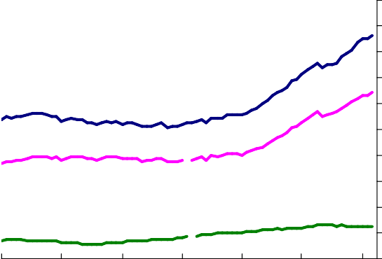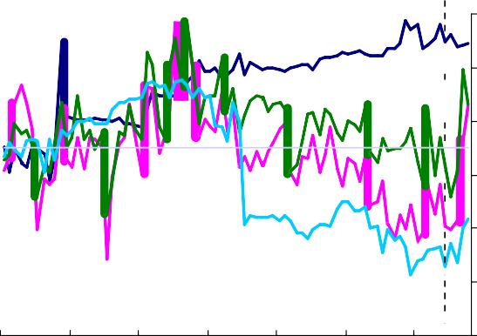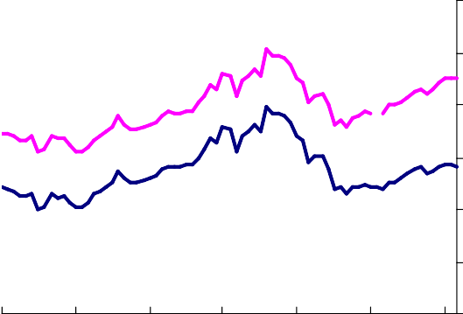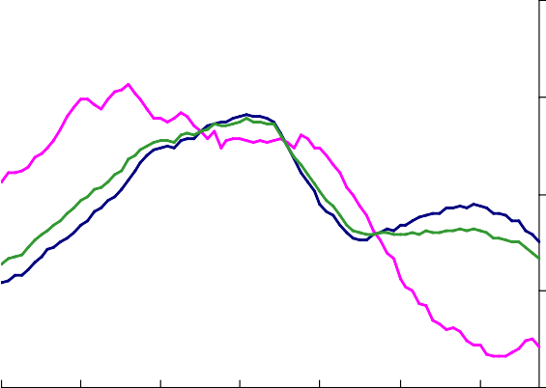

|  |  |  |  |  |  |  |  |
| --- | --- | --- | --- | --- | --- | --- | --- |
| Chart 3: Financial and housing wealth to income  ratios | | | Chart 4: Secured and unsecured lending growth | | | | |
| 1989 | **Total financial**  1992 1995 | Per cent  6  5  4  3  2  **Net financial wealth**  1  0  1998 2001 2004 2007 | 2001 | 2002 | 2003 | **Total**  2004 | Percentage changes oya 20  16  **Secured** 12  8  **Unsecured**  4  2005 2006 2007 |

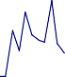

Unexplained Consumption growth

­4

­2

0

2

|  |  |  |  |  |  |  |  |
| --- | --- | --- | --- | --- | --- | --- | --- |
| Chart 5: Household saving to income ratio | | | | | | | Chart 6: HEF index and aggregate FES consumption  growth |
|  |  |  |  |  |  | Per cent |  |
|  |  |  |  |  |  | 14 |
|  |  |  |  |  |  | 12 |
|  |  |  |  |  |  |  |
|  |  |  |  |  |  | 10 |
|  |  |  |  |  |  | 8 |
|  |  |  |  |  |  | 6 |
|  |  |  |  |  |  | 4 |
|  |  |  |  |  |  | 2 |
| 1989 | 1992 | 1995 | 1998 | 2001 | 2004 | 2007 |

|  |  |  |  |  |
| --- | --- | --- | --- | --- |
| Chart 7: Contribution of HEF index to aggregate FES consumption growth | | | | |
| .5 | 1  HEF index  Unexplained Consumption growth | 1.5 | Fitted values | 2 |